# UW Results Frequency Project

**PROJECT OVERVIEW**

|  |  |  |  |
| --- | --- | --- | --- |
| **Project Manager:** | Richard Yoon | **Project Sponsor:** | Joy Johnstone |
| **Projected Start:** | TBD | **Projected Finish:** | TBD |

**Project Background:**

One of our largest clients, University of Wisconsin, has requested that instead of sending our results weekly, they would like them daily. This includes both the specific lead data, as well as the sales report summaries. As these results are tabulated and formatted manually each week, completing it daily will significantly increase the workload on our Sales Support. Since our Sales Support is already at approximately 110% workload, they will not be able to absorb this drastic volume of work.

**Project Objective:**

To be able to send the lead results to the University of Wisconsin daily, without increasing the ongoing workload on the Centron team.

**Success Criteria:**

* Ability to send daily lead and reporting results to the University of Wisconsin
* Reduce Sales Support effort within the Send Results process by 80% (220 minutes to 44 minutes) through automation and process efficiency gains

**PROJECT DETAILS**

**Approach:**

* Develop a piece of custom software to track UW leads and their statuses
* The custom software shall have the ability to generate the necessary lead file and reports in their proper formats for UW
* Project methodology will be iterative

**Project Schedule/Milestones:**

TBD

**Budget Information:**

Keep the full project less than $100,000

**PROJECT TEAM**

**Roles and Responsibilities:**

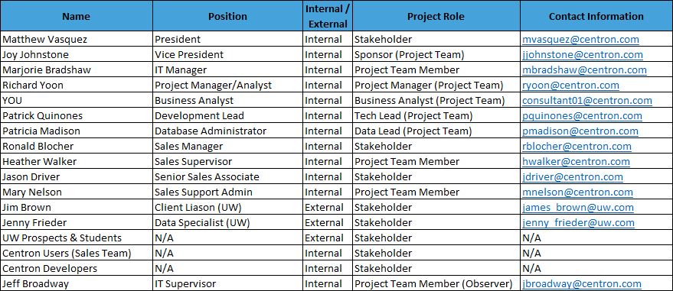

**Stakeholder Comments:**

Nothing to note currently

**APPROVAL SIGNATURES**

|  |  |  |  |
| --- | --- | --- | --- |
| Joy Johnstone |  | Richard Yoon |  |
| Joy Johnstone,  Project Sponsor |  | Richard Yoon,  Project Manager |  |